Riding in Brisbane guide

Helping you ride around Brisbane safely and confidently

Information and inspiration for your next riding experience

Contents

Welcome from the Chair 3
Let’s get riding 4
Free workshops 5
Getting around Brisbane by bike 6
BMX riding and mountain biking 8
Riding safely 10
Brisbane’s bikeway network 13
Map of Brisbane inner-city 14
Map of Brisbane North 16
Map of Brisbane South 18
Map of Brisbane East 20
Map of Brisbane West 22

Disclaimer
The material contained in this guide has been researched, assembled and included with all due care.
Information contained in this guide is correct at the time of printing. Brisbane City Council should not be held responsible or liable for any losses, damages, charges and/or expenses incurred or sustained by any party relying on the material contained, incorporated or included in this guide. All editorial, maps and photographs appearing in this guide are strictly protected by copyright.
For more information, visit cyclingbrisbane.com.au or call Council on 3403 8888.
Welcome from the Chair 1
Let’s get riding 2
Free workshops 3
Getting around Brisbane 4
Riding safely 6

South 16

Welcome from the Chair
Every day, Brisbane City Council works with residents and local communities to make sure Brisbane is the best place to live, work and play – and that means a city which allows us to walk and ride easily and safely.

More people than ever are exploring their local neighbourhoods and looking for active and healthy ways of travelling to school or work.

Council is committed to expanding our city’s active transport network to deliver safe, convenient and connected pathways for Brisbane residents, visitors and commuters. Encouraging active transport is all part of our balanced approach to reducing traffic congestion and a great way to stay active and healthy.

Since 2020, Council has delivered its largest investment in Brisbane’s public and active transport network with projects including the Indooroopilly Riverwalk, new green bridges and new bikeways.

With strong investment in our extensive active travel network and programs, Council continues to be dedicated to improving safety, connectivity and accessibility for Brisbane’s residents and visitors. Over the last two years, Council’s active transport network has evolved to provide more opportunities for riding and walking.

Whether it be for fun, fitness or the commute, I encourage you to take advantage of our safe, well-connected city and enjoy our beautiful Brisbane lifestyle by exploring the city on two wheels.

I look forward to seeing you out and about on Brisbane’s bikeways.

Cr Ryan Murphy
Civic Cabinet Chair for Transport

Let’s get riding
Cycling Brisbane is Brisbane City Council’s free membership program that aims to make it easier for everyone to get riding and stay active in Brisbane.

Showcasing Brisbane’s extensive active transport network, Cycling Brisbane provides access to free bike skills workshops for everyone and shares simple ways that riding can become part of your everyday life. Regular e-newsletters will share the latest riding news, tips and tricks to get you started or keep you riding.

Join more than 25,000 people who have already signed up to Cycling Brisbane for free at cyclingbrisbane.com.au

Stay in touch via Instagram @cyclingbrisbane and remember to tag #cyclingbrisbane on your riding adventure.

To help you take your riding adventures up a gear, we’ve compiled a list of the best Brisbane rides and bike paths to try. There’s something for everyone: joy riders, sightseers, families, scenery‑seekers, mountain-climbers and more.

Looking for some inspiration?

Check out our guides to Brisbane’s best rides

Free workshops
Cycling Brisbane delivers a range of free workshops, allowing you to ride with improved confidence, skills and knowledge.

Our range of workshops are suitable for all ages and skill levels.

- Children: Kids can learn to transition from training wheels to two wheels and develop skills to have fun off‑road and on bikeways.
- Electric bike tasters: Try out a pedal‑assisted electric bike.
- Riding on the road: Learn tips and techniques for riding on the road.
- Refresher riding: Build your skills and knowledge to regain the confidence to start riding regularly again.
- Mountain biking: From basic skills to trail obstacles for beginner, intermediate and advanced levels.
- Maintaining a bike: Learn to change a tyre and keep your bike in working condition.
- E-scooters: Pilot of skills workshops to learn to ride safely and confidently on Brisbane’s bikeways, shared pathways and roads, where permitted.

Scan the QR code
To learn more about the range of workshops we offer

Getting around Brisbane
Brisbane’s bikeways are a great way of getting around Brisbane, with convenient connections to public transport and bike facilities.

Council is building a bikeway network for the whole city. Combining a bike ride with public transport can be a very practical way of getting to your destination.

Taking your bike or scooter on public transport
Bikes and privately owned scooters, are allowed on Brisbane trains at all times. However, there are some conditions about which carriages you can travel on. Visit queenslandrail.com.au for full details.

You can take your bike on the CityCat and CityFerry, provided there is enough space. CityCats have bike racks at the rear of the vessel.

Passengers with folding bikes or kick scooters can travel on any mode of public transport at any time.

Parking and locking your bike or scooter
Parking for bikes and scooters is provided at most ferry terminals and train stations and at all busway stations. There are a range of bike shelters, racks, lockers and facilities located across Brisbane.

Scan the QR code
To find out more information on bike parking and facilities.

You can also park your bike or scooter at a variety of public racks across the city.

Taking care of your bike and scooter
Here are some simple tips to help keep your bikes and scooters safe from theft:
- invest in a good quality lock
- store your bike or scooter in a secure place, as opposed to a communal area if possible
- take note of your bike or scooter serial number and register it with Queensland Police Services
- consider concealing a small GPS tracker on your vehicle.

Cycling Brisbane runs regular free workshops on how to maintain your bike. Scan the QR code on page three to learn more and book your spot at the next bike maintenance workshop.

Council also has over 14 repair stations located along Brisbane’s extensive bikeway network. For repair station locations, visit cyclingbrisbane.com.au/new-riding/look-after-your-bike
Tip
When parking and locking your bike or scooter, we recommend using a D-lock to safely secure both the wheel and the frame.

Riding Safely
Wherever you ride, you will be sharing the space with other people. Always ride at a safe speed and consider other people using the road, bikeway or shared path.

Remember that in Queensland, you are required to wear a helmet when riding a bike or scooter. You also need to:
- keep at least one hand on the handlebars
- use a front and back light at night
- have a bell fitted to your bike.

Riding on footpaths and shared pathways
You can ride on the footpath in Queensland unless there are signs or markings stating otherwise. People walking have priority, so be sure to give them space and travel at a speed that will allow you to stop and avoid collisions. Be aware of other people on these paths and be sure to ring your bell to make other people aware of your approach.

Scan the QR code
To watch Cycling Brisbane’s animation video on sharing paths and roads

E-mobility
Emerging new e-mobility technologies, particularly e-bikes and e-scooters, are becoming increasingly popular and many new riders are joining Brisbane’s extensive active travel network.

Hire an e-scooter or e-bike
Council partners with Neuron and Beam to give people freedom, choice and access to use e-bikes and e-scooters around the city. Hiring an e-bike or e-scooter is the perfect way to see the city, ride to an event, commute to work, or to use when getting to and from public transport.

There are a range of flexible hiring and membership options to suit everyone including one off trips or daily, weekly and monthly hire.

Give it a go!
Whether you’re starting out, looking to learn new skills or just want to try out an e-mobility device, we’ve got you covered.
- Register to be involved in e-bike or e-scooter workshops with Cycling Brisbane cyclingbrisbane.com.au/about-our-workshops-events.
- Get out and take a ride on our network of bikeways. It’s the
- safest and most enjoyable way to start your e-mobility journey cyclingbrisbane.com.au/bikeways.
- Take a ride with one of our e-mobility partners.

Scan here to try Beam
Scan here to try Neuron

Want to know where you can and can’t ride your scooter or e-bike? Visit cyclingbrisbane.com.au/e-wheeling to find out more.

BMX riding and mountain biking
BMX riding and mountain biking are two of Australia’s fastest growing recreational activities, with both now considered Olympic sports. Brisbane has plenty of facilities for these popular types of riding.

BMX riding
BMX riding is an outdoor sport that the whole family can enjoy. There are more than 20 parks across Brisbane that offer BMX facilities for fitness, fun and recreation and cater for different skill levels. Council has also completed two state-of-the-art tracks at Bracken Ridge and Darra BMX parks.

Visit brisbane.qld.gov.au and search ‘BMX parks’ for a list of BMX facilities.

Mountain biking
Mountain biking is a great way to explore the outdoors with each ride presenting unique challenges based on the environment. South East Queensland has a number of mountain biking areas catering to a range of ages and abilities. Some of the most popular are:

• Bayview Conservation Park
• Bunyaville Conservation Park
• Daisy Hill Conservation Park
• Eastern Escarpment Conservation Area
• Mt Coot-tha Forest
• Redlands Track Park.

For more information about mountain biking, including trail maps, virtual tours and videos and how to book free mountain biking and BMX skills workshops, visit cyclingbrisbane.com.au/riding-types and select ‘mountain biking’.

Riding on the road
When riding on the road, you must obey the general road rules as well as the specific road rules for bike riders. You can ride on the road and in bike, bus and transit lanes.

You can choose to ride in a bike lane where one is provided but you don’t have to. Bike riders can ride two abreast but must stay within 1.5 metres of each other.

When riding on the road, remember to be aware, be safe and be seen. To learn skills and tips for riding on the road, register for one of Cycling Brisbane’s ‘Bike riding skills for adults’ workshops at cyclingbrisbane.com.au/events

Remember: one metre matters
In Queensland, it is compulsory for people driving a car to stay at least:
- one metre away when passing a bike rider in a 60km/h or lower speed zone
- 1.5 metres where the speed limit is more than 60km/h.

The minimum passing distance also applies when you want to go around two people on bikes who are riding beside each other.

Scan the QR code
To find out about the rules for riding e-scooters on roads

Brisbane’s bikeway network
Use these simplified maps of some of Brisbane’s bikeway network to see where you can ride in the city.

Brisbane is home to an extensive network of bikeways and shared pathways. These are a great way of getting to and from a variety of destinations such as shops, parks, cafes, bus and train stations, schools and universities.

Did you know that one of Brisbane’s best bikeways might be closer to you than you think?

One third of people in Brisbane live within 300 metres of at least one of the bikeways featured below, and almost two thirds live within a kilometre.

These maps show a selection of the popular routes that you can take by bike, scooter or on foot.

Be inspired to ride somewhere near to you or find out what other parts of the city you can explore on wheels. It’s time to get riding and explore Brisbane’s bikeways!

Scan the QR code
For more detailed information and journey planning suggestions

Brisbane bikeway maps

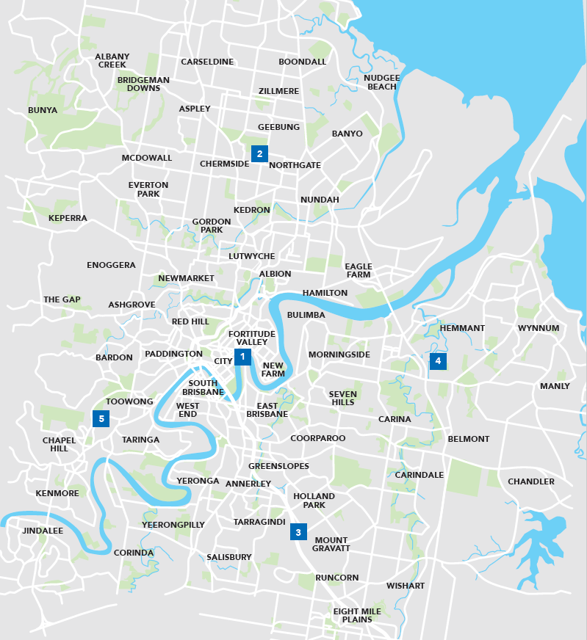

- Brisbane inner city
- Brisbane North
- Brisbane South
- Brisbane East
- Brisbane West

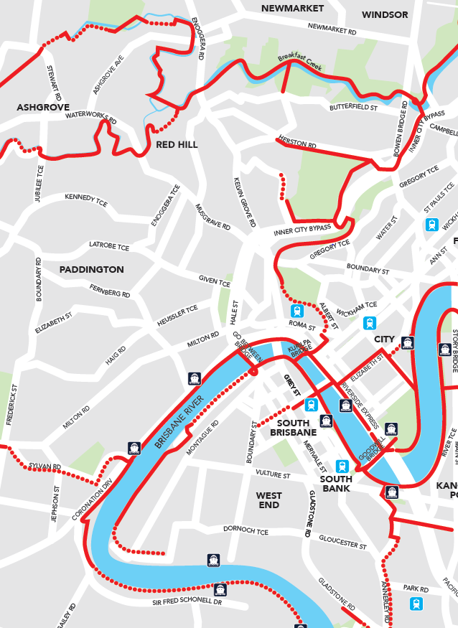
Brisbane inner city

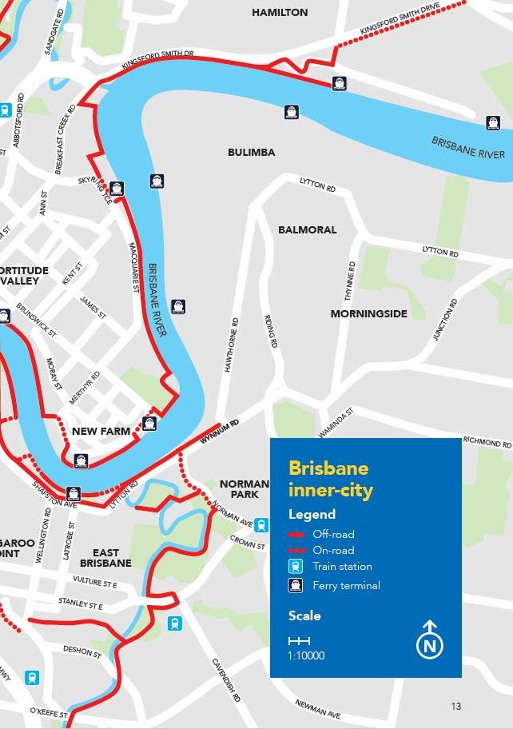

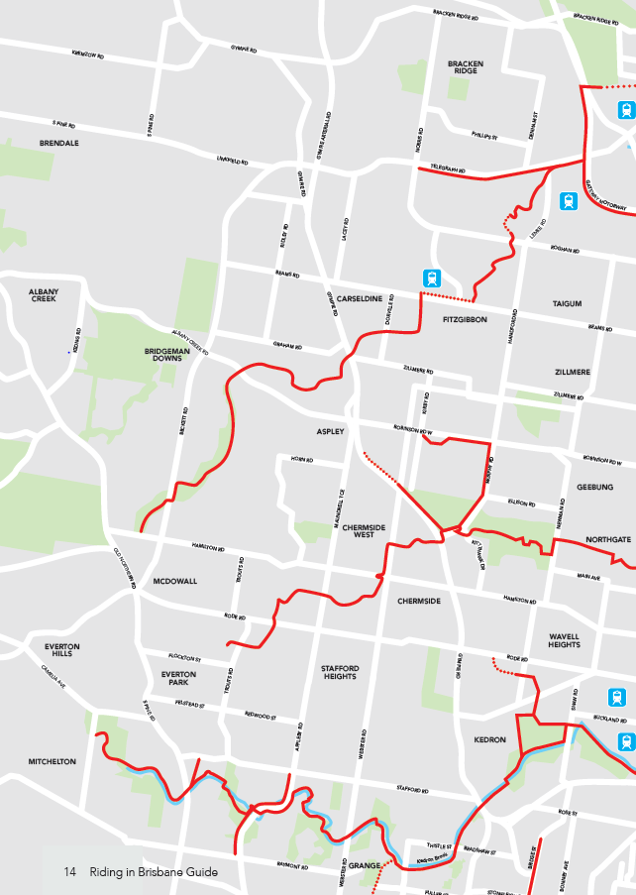
Brisbane North
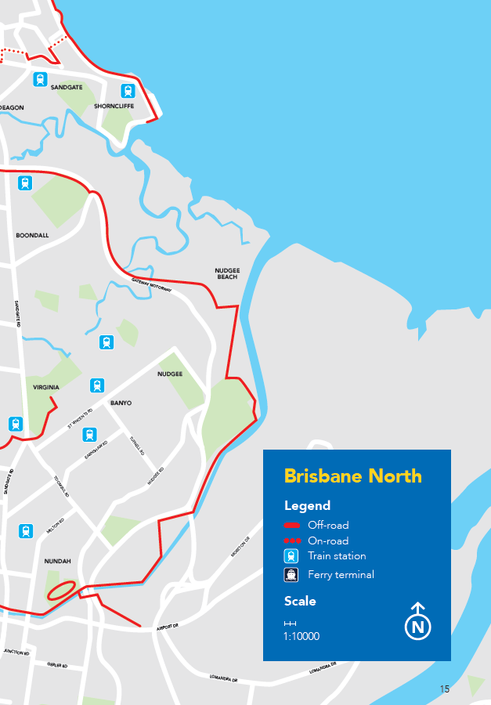

Brisbane South

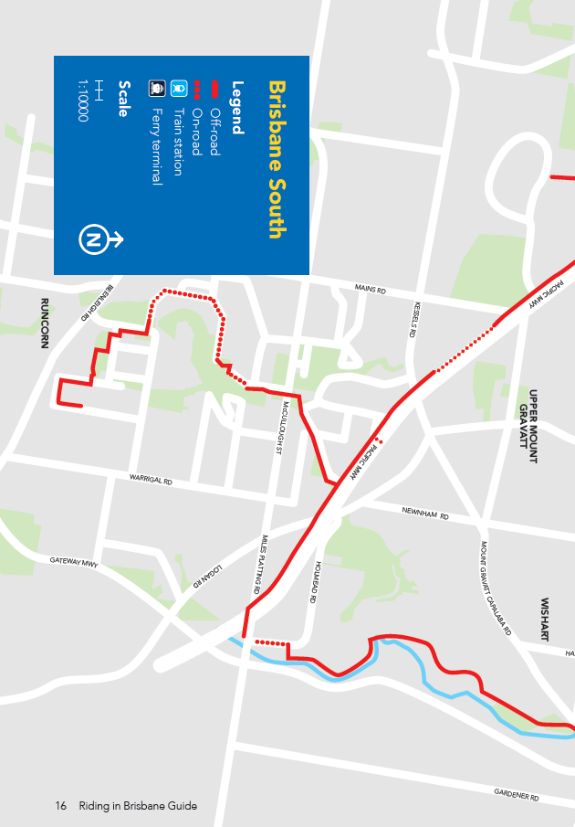
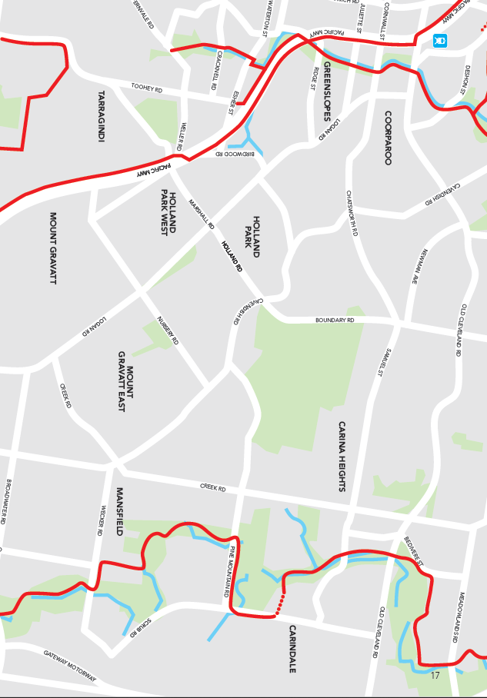

Brisbane East

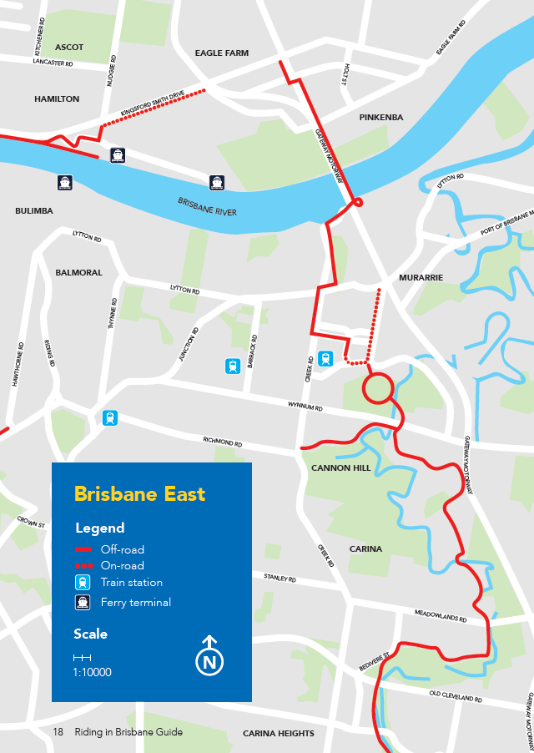
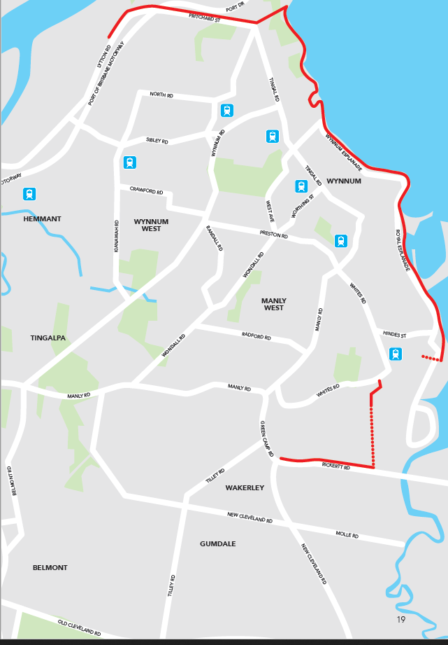

Brisbane West
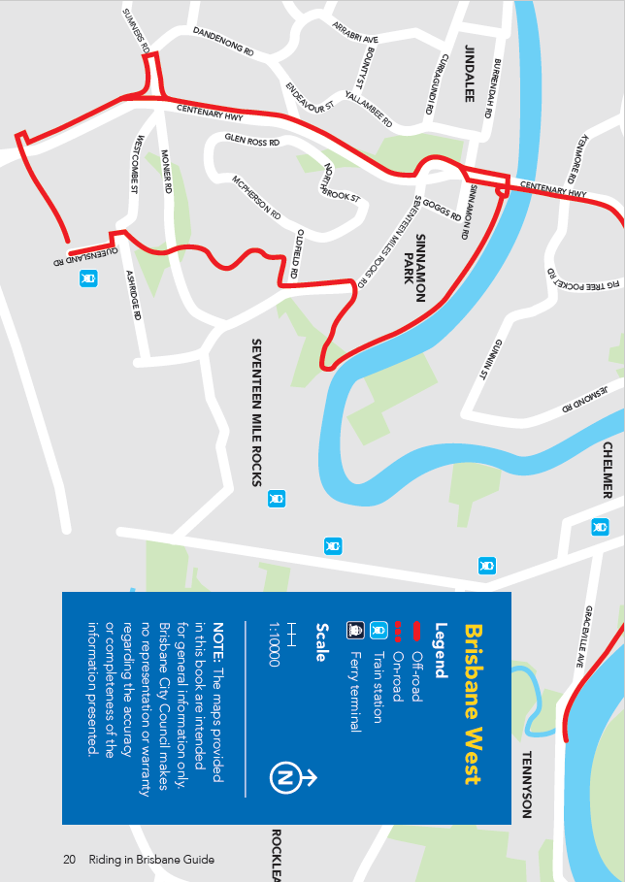

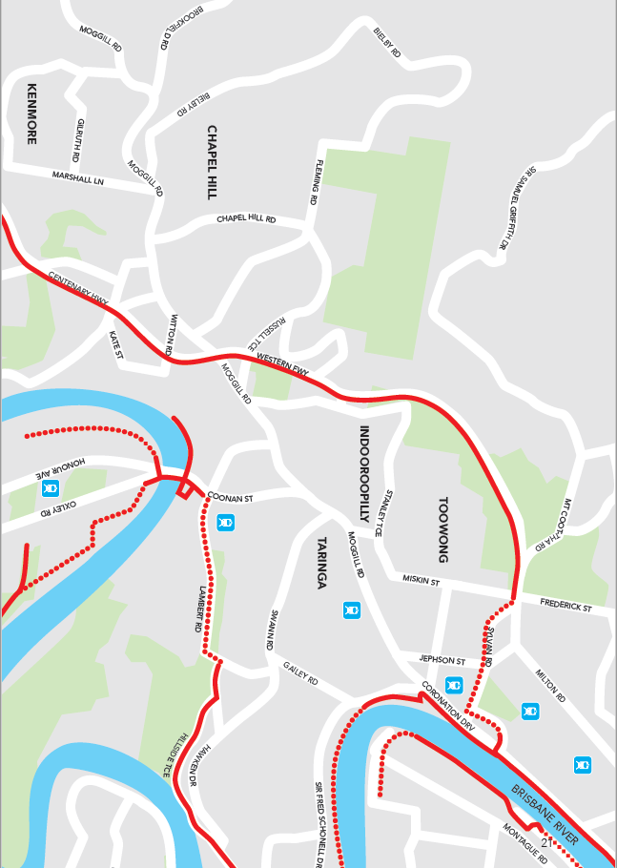

Share your two wheel adventure @cyclingbrisbane or via #cyclingbrisbane
cyclingbrisbane.com.au

Brisbane City Council
GPO Box 1434
Brisbane Qld 4001

Every effort is made to ensure that information is correct at time of printing
Printed on sustainable paper

CA21-1240025-01-6090
©2022 Brisbane City Council

brisbane.qld.gov.au
3403 8888

Facebook: /BrisbaneCityCouncil
Twitter: @brisbanecityqld
Instagram: @brisbanecitycouncil

